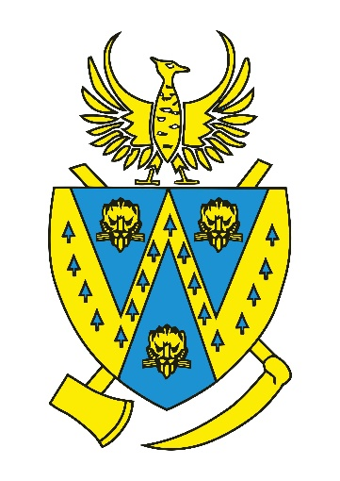
Annual Parish Meeting – Wem Urban
Thursday, 13th March 2025 at 7:00 PM
The Town Room, Wem Town Hall

AGENDA
1. Approval of Minutes
A quick look back at last year's key discussions and decisions.
2. Wem Sportsperson of the Year Awards
Come and celebrate the fantastic achievements of Wem’s top athletes. Wem Sports & Social Association will be honouring our local sports stars.
3. Wem Town Council Grants – Celebrating Local Projects!
Find out how last year's grants made a difference in Wem. Local groups will share the impact of funding received and we’ll also reveal the lucky recipients of the 2025-26 grants.
4. Open Forum – Your Town, Your Voice!
Have ideas, concerns, or suggestions about our community? This is your chance to speak up and help shape Wem’s future.
Everyone is welcome! Let’s come together to celebrate, discuss, and make Wem an even better place to live. See you there!


Cllr David Parry
Town Mayor

